ECE 24-401: Battery Vampire 2.0

**Final Design Report**

Prepared for

Professor Atkinson

By

Bruno Da Silva (ECE)

RJ Dalusung (ECE)

Yanal Matar (ECE)

Ryan Rolle (ECE)

May 2nd, 2023

**Contents**

**1 Executive Summary……………….………………………………………………….……3**

**2 Introduction…..…………………………………………………………………………….4**

**3 Project Definition……………………………………………….………………………….5**

**3.1 Goals………………………………………………..………..………………………….5**

**3.2 Objectives.………….………………………………………………..….………………6**

**3.3 Constraints………..…………………………………….………………….…………..6**

**3.4 Codes and Standards….……………....……………….………………………………7**

**4 Design Methodology – Validation and Verification……………………………………...7**

**4.1 Computational Methods (e.g. FEA Modeling, Circuit simulations, etc.)…………..7**

**4.2 Experimental Methods ………………………………………………………………10**

**4.2.1 Test Set-Up and Instrumentation………………………………………………….10**

**4.2.2 Testing Procedure and Measurement………..………………………………...…..10**

**5 Results…………………………………………..……………………..…………………..11**

**6 Additional Design Considerations……………………..…………………………...……13**

**7 Cost Analysis……………………………………………………………………………...14**

**8 Conclusions and Recommendations…………………...……………………….………..15**

**References…..…….………….………………………………………………………………….16**

**Appendix A – Team Contract………………………………….……….…………..………….17**

**Appendix B – Schedule/Timeline……………………………………….…………..………….24**

**1 Executive Summary**

This project endeavors to create a Battery Recharge System, a user-friendly and energy-efficient solution designed to recharge "dead" alkaline batteries and nickel metal hydride (NiMH) rechargeable batteries. The system's core features will be designed to work with AA batteries, an emphasis on energy efficiency to reduce environmental impact and operational costs, and an intuitive user interface to simplify battery loading and charging. The final design will involve using the circuitry of our device to extract energy from dead batteries and then use this energy to charge rechargeable batteries. By implementing a system along the lines that we have just described we hope to promote sustainability, provide cost savings to the user, while also doing this in a convenient way to users. The project is scheduled to proceed through design, development, testing, production, and launch phases to bring this innovative solution to market.

This project is a revitalization and a reimagining of the original Battery Vampire, a senior design project from last year. While last year's end product created a device that could capture the energy from dead batteries and put that energy into a power bank there were many aspects of this end result that we hope to improve upon this year. For instance instead of putting energy into a power bank we hope to be able to use the dead batteries to charge dead rechargeable batteries, as this is more inline with the original vision of the project. We also hope to create a device that is able to perform this function in a relatively timely manner with greater energy throughput then the original as these were also areas where the original product could be improved. The charging of the power bank took awhile and then when it was done it had not been charged very much. We hope that our product will be able to meet the desired design specifications without falling into the same pitfalls.

By creating a tool that allows for the easy recycling of leftover power in old batteries we hope to reduce the demand for single-use batteries. This battery recharge system not only offers users substantial cost savings, but also contributes significantly to environmental sustainability by curbing battery waste. Through its versatile compatibility, user convenience, and eco-friendly attributes, this project aims to revolutionize the way people engage with battery management.

* Experimental Design -10/20/23
* Experimental Data - 11/1/23
* Functional Diagram - 11/7/23
* Fall Poster - 11/17/23
* Preliminary Report - 12/15/23
* User Guide - 2/15/24
* Final Product - 4/1/24
* Spring Poster - 4/1/24

**2 Introduction (i.e. Background, “Literature Review”)**

Batteries have a long and storied history. They were first introduced in the early 20th century and the standardized size of batteries was fleshed out a few years after World War II concluded. Since their creation the battery industry has evolved into a multi-billion dollar industry which spans the world over. In the United states in 2021, 7.730 Billion dollars were spent on alkaline batteries. However what once offered a simple solution to providing portable gadgetry with electricity without needing to plug into a wall outlet has had some unintended side effects as the industry has ballooned in size. With 4 billion AA batteries produced worldwide every year, and 180 thousand tons of hazardous waste in the US alone created by the populus throwing away old batteries. With a modern concern for the health of our environment and reducing the amount of waste produced, this project hopes to address both of these concerns by creating a gadget to effectively recycle the energy left in old batteries and use this energy to charge rechargeable batteries. Ideally this would help lessen the amount of batteries that the average person needs to buy and therefore also lessen the impact on the environment that results from throwing away so many toxic metals.

At its core, our mission is to design a revolutionary system—an energy-efficient, optimized, and user-friendly system. This system is envisioned to simplify the process of resurrecting seemingly "dead" alkaline batteries, breathing new life into them by recharging nickel metal hydride batteries. This transformative design will not only offer a practical solution but also incorporate intuitive indicators, ensuring that consumers are always informed about the status of both their dead batteries and rechargeable counterparts.

The real-world scenarios envisioned in this project add depth and practicality to our endeavor. Testing will simulate diverse scenarios, from batteries with uniform voltage to those with varying voltages and brands. This comprehensive testing regimen will ensure that our solution is both robust and adaptable. As the crowning achievement, this project will culminate in the creation of a simple user guide. This guide will elucidate the optimal use of the product for consumers, ensuring that the benefits of this innovation are accessible to all.

In summary, our project aspires to improve the way we perceive and interact with batteries. By designing a consumer-friendly system that resuscitates "dead" alkaline batteries, we not only meet a pressing engineering need but also contribute to the broader objectives of sustainability and resource efficiency. This introduction has set the stage for a journey of innovation, exploration, and impact, one that promises to redefine the battery ecosystem for generations to come.

**3 Project Definition**

This section describes the goals and objectives of the project, as well as all realistic constraints to which the design is bound. The following design criteria were developed in order to achieve the unmet engineering need presented in the introduction.

* 1. **Goals**

The following list provides the goals established by Professor Atkinson

* Design an energy-efficient, optimized, consumer-friendly system that makes it a simple task to load in “dead” alkaline batteries and use it to charge up nickel metal hydride rechargeable batteries.
  + The system must be optimized and power efficient so we can transfer as much energy as possible to the rechargeable batteries.
  + The system must be self-sustaining, meaning, it’s not allowed to use external power for any functionality.
  + The system will have circuitry that allows for measurements of the energy in the dead batteries and also measurements of the energy in our rechargeable batteries.
* Test the system to determine the cost savings in reduced battery consumption.
  + How many fully recharged “free” batteries can typically be obtained from a typical set of “dead” batteries?
  + The tests should show that the product has merit by reducing energy waste.
  + A key goal is to determine the energy stored in both types of batteries as a function of voltage remaining.
* Design and perform experiments to give us necessary background information for the final product:
  + How much of the energy that is stored in the dead batteries is actually transferred to the rechargeable batteries?
  + Must carry out experiments to determine whether a buck boost converter would work more or less efficiently than a simple circuit that uses the dead batteries as a supply for a voltage regulator.
  + Conduct an experiment to determine how many “dead” batteries are needed to light up a single LED (Indicating it has reached a desired voltage). Once the LED is on, flip a switch so that NiMH starts charging.
  + Carry out an experiment to make another LED indicator light up once rechargeable batteries are done charging.
* Test the system in various real-world scenarios to determine the practicality, optimal usage and limitations of the system. Example test cases might be:
  + All the dead batteries have approximately the same voltage
  + The dead batteries have different low voltages
  + All the batteries are the same brand
  + The dead batteries are of different brands
  + The dead batteries have both different voltages and different brands
  + One or more of the dead batteries has reached a point where they no longer efficiently transfer energy (i.e. this will determine when the dead batteries are completely dead and should be removed)
* Write a simple user guide that explains the optimal use of the product for a consumer.
  1. **Objectives**

The following list describes the objectives of the project in a specific, measurable, achievable, realistic, and time bound manner. These objectives ultimately lead to the design specifications and constraints to be set in the next section of the report.

* The system will transfer energy efficiently from ‘dead’ batteries to nickel metal hydride rechargeable batteries.
* The system will measure and display energy stored of both ‘dead’ and rechargeable batteries on a low power LED indicator.
* The system will reduce the amount of batteries the customer will have to buy every year.
* The system will reduce the overall number of batteries customers put into landfills.
* The system will be convenient to use.
  1. **Constraints**

The following provides a list of constraints that includes design specifications, metrics, and target specifications. These are specific and are able to be measured and tested. Each constraint is subdivided into primary sections such as manufacturability, cost, functionality, and codes and standards. It must be noted that the bullet points provide a detailed description.

Manufacturability Constraints:

* The device must be made from readily available materials.
* Individual components must be standardized and easily accessible with a short delivery time.
* Total design weight
* Total design cost
* Total design size

Efficiency Constraints:

* The system must be efficient enough to justify the purchase.
* The system must provide the customer with long-term cost savings.
* The indicators might not be energy efficient, thus will need to be minimized

Functional Constraints:

* The system might only function with a specific brand of AA batteries.

Code/Standard Constraints:

* Design must adhere to all applicable IEEE/ANSI standards

### 3.4 Codes and Standards

Below is a list of codes and standards that will be or may become relevant to the project as it is completed. The relevant codes and standards found for this project, as well as a brief description of them, are as follows:

• NFPA 70—National Electrical Code —The codes outlined here will help ensure that the project does not become a fire hazard

• NFPA 70E—Standard for Electrical Safety in the Workplace —This code is another measure to ensure safety when building our prototype

• IEEE Std 1679–Standard for characterization and evaluation of alkaline batteries—This standard will help us to ensure industry consistency when using NiMH batteries

• ANSI C18.2M–Portable Rechargeable battery specifications— This standard will help with making sure that the rechargeable batteries are implemented into our system safely

**4. Design Methodology – Validation and Verification**

The following provides an explanation of the approach and criteria used to develop and evaluate the proposed design. Provided details of any computer-aided modeling techniques used to evaluate the design including the software used and assumptions. Also included, is a detailed description of any experimental testing methods including test equipment, instrumentation, and testing procedure.

**4.1 Computational Methods**

Our computational methods involve circuit simulations on MATLAB to avoid charging and discharging AA batteries for an extended period of time. We plan to use MATLAB to verify that the voltage and current supplied to the rechargeable batteries are sufficient. The MATLAB simulation will be restricted to the output of the buck boost converter and not the whole system. In addition to the MATLAB simulations, we will experimentally test the system in different configurations to find the optimal solution for our prototype.

First, using Duracell's discharge datasheets, we loaded the data into MATLAB as voltage vs time curves. These plots then convert into power vs time curve using Eq. 1, where the current is the constant discharge current rate. We then converted the power vs time curve into energy remaining vs time using Eq. 2. Finally, the Energy is plotted against voltage. Fig. 1 shows the step by step process in terms of plots for both non-rechargeable (on the left) and rechargeable (on the right) batteries. Fig. 2 shows the final result of Energy Remaining vs Voltage plots explicitly.

$Power=Current*Voltage$ (1)

$Energy=\frac{\int{}Power dt}{Energy_{max}}$ (2)

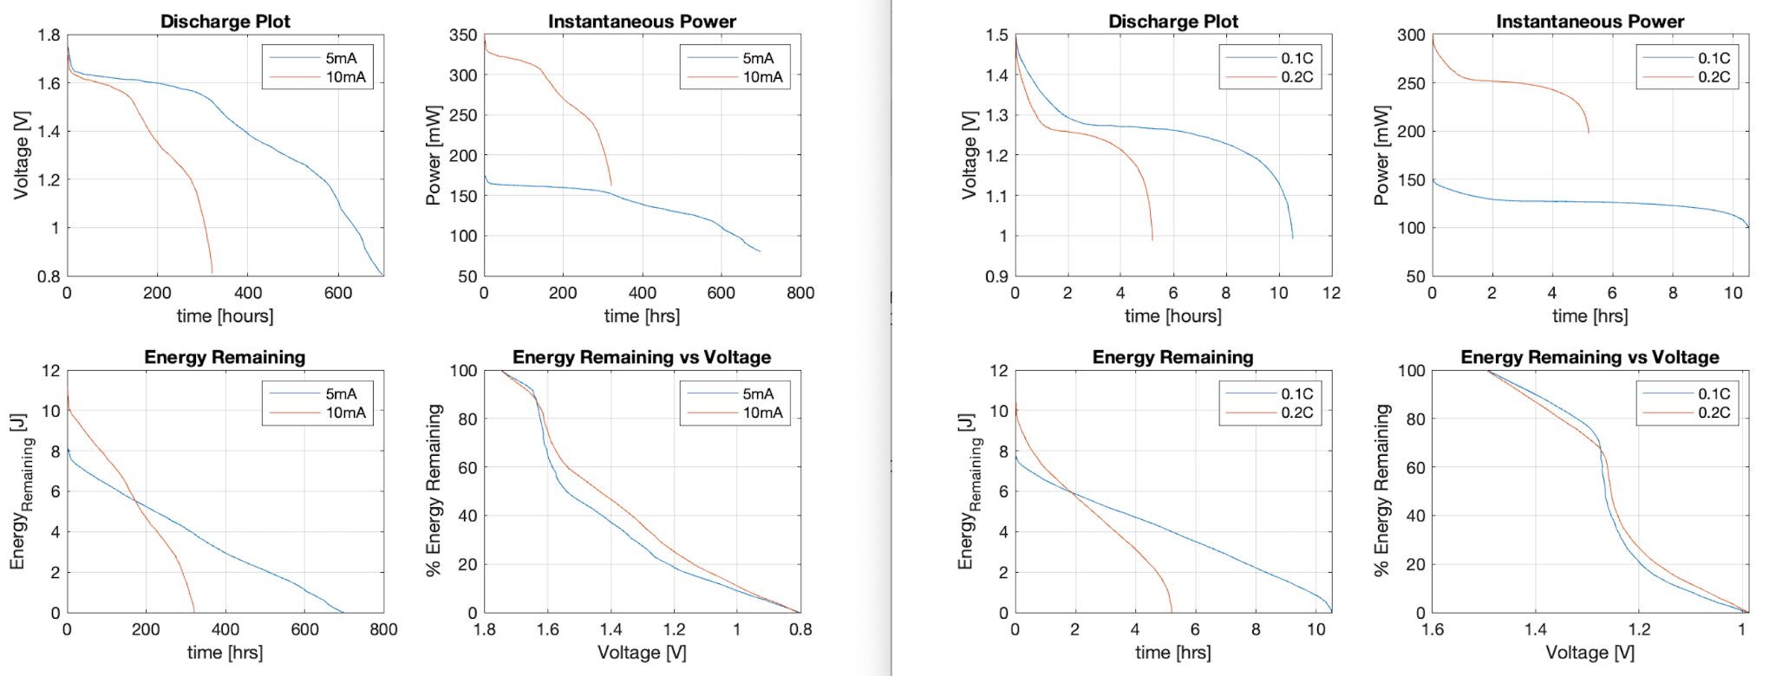

**Figure 1:** Discharge Curves Conversion Plots

The purpose of the curves in Fig. 2 is to help identify the amount of “dead” batteries needed to recharge one “dead” rechargeable battery.We were able to come up with the conclusion that four “dead” batteries are needed to charge one “dead” rechargeable from the plot. This plot was also crucial for determining the efficiency of our system through the use of the voltage drop in the “dead” batteries from the charging process and the corresponding drop in energy remaining in the batteries. This measured value can then be used in conjunction with the energy remaining gained in the rechargeable batteries from the charging process.

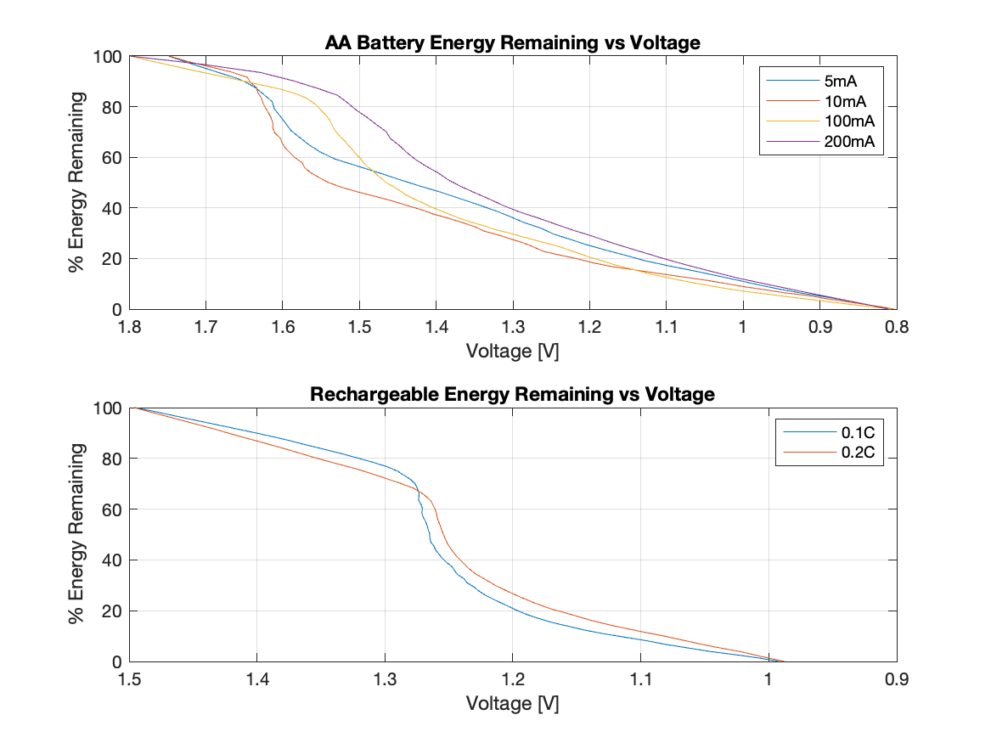

**Figure 2:** Energy Remaining vs Voltage Plots

Initially, we ran the simulations with the circuit diagram shown on Fig. 3; however, once we decided on the four-to-one ratio of “dead” to rechargeable batteries, we set out to create a basic circuit simulation in MATLAB’s simscape tool, shown on Fig. 4. We tested multiple resistor values in order to supply the rechargeable battery with our target current of 25mA, 0.01C for a 2500mAh battery. The simulations were done with a model rechargeable battery with the same parameters supplied by the Duracell website. With the stable 5.2V output from the buck-boost converter used as the source for the circuit, we found that the two parallel resistors should be 100 ohms each to both reduce the current to the desired 25mA, or close to, and lower the current enough to not burn out the LED.

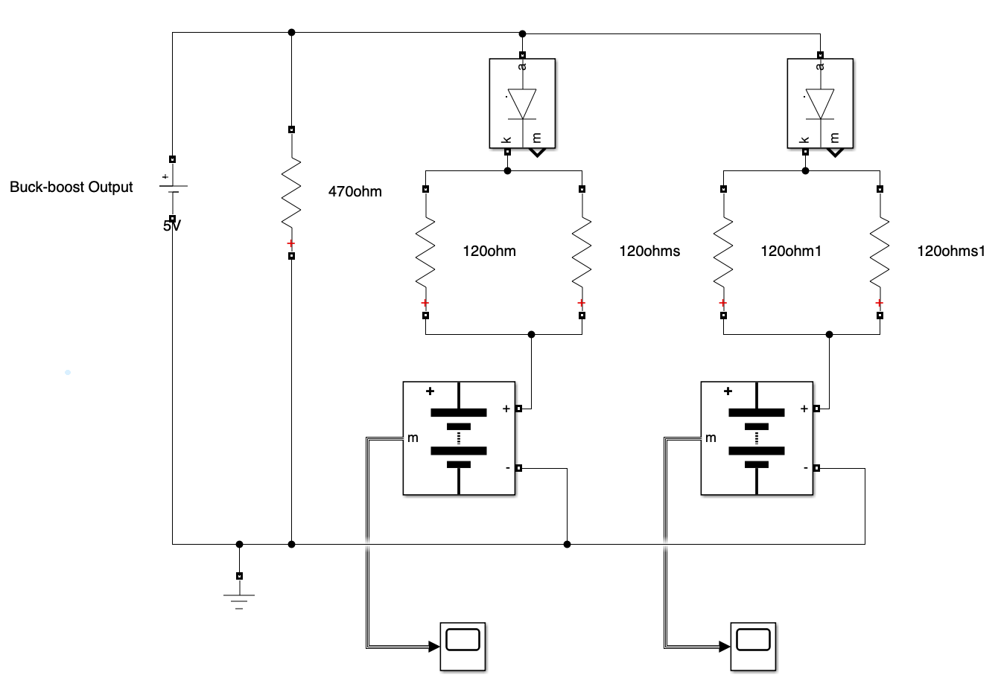

**Figure 3:** Initial Circuit Diagram

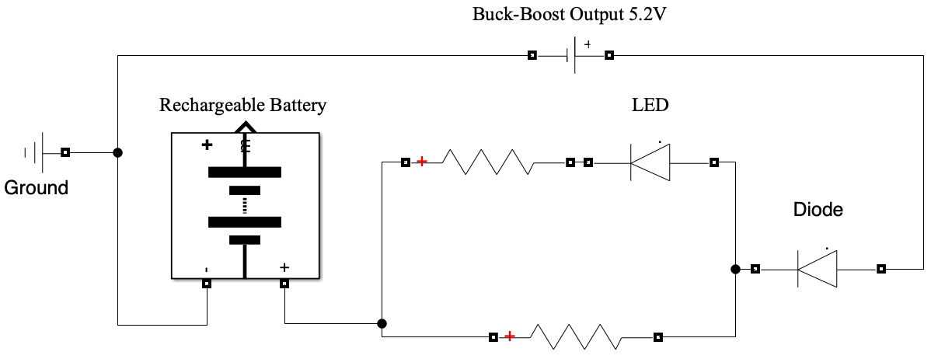

**Figure 4:** Final Circuit Diagram

**4.2. Experimental Methods**

Our experimental procedure involved us building the circuit shown in Fig. 4, above, and testing it with variations in the “dead” batteries’s voltages . There were prior experiments where we tried different resistor values as well as charging two rechargeables using the same quantity of “dead” batteries, four (as shown in Fig. 3). However, the process explained in the Computational Methods above suggested that the circuit diagram in Fig. 4 will work best with our intended target charging rate, 0.01C. The following sections 4.2.1 and 4.2.2 will provide further explanation of the experiments used to verify/finalize our design.

**4.2.1. Test Set-Up and Instrumentation**

The way we measured the majority of our data was through multimeters and virtualbench. We also made sure to carry out calculations to compare with our experimental value. Our test set-up depended on what type of data we were attempting to collect. The process usually consisted of designing the circuit first on MATLAB or MultiSim. We made sure to build these circuits in a virtual environment first so that we could pick different values and experiment with different components without jeopardizing any equipment. This also helped us come up with the correct values for certain components before we began actually putting the circuit together on our breadboard.

When it came to charging and discharging our batteries, there were multiple ways we were able to achieve this. We built several charging circuits to charge the batteries using a DC input. For discharging the batteries, the main way we did this was to simply connect the battery across a resistor and wait for it to discharge. Voltage generators and probes were very useful throughout our testing process.

An important part of our test set up was transferring our initial prototype we built on a breadboard to a PCB board where we could solder the components together. For this, we of course used a soldering kit and had to make sure our circuit was still working properly after soldering everything. Once we had a functional prototype on our PCB board, we carried out some timed tests to determine how efficient our design was and we could improve it, which is discussed in the “Testing Procedure and Measurements” portion of this report.

**4.2.2. Testing Procedure and Measurements**

The testing procedure for charging and discharging batteries on a breadboard involves several steps to ensure accurate measurements and reliable results. First, our breadboard is set up with the necessary components, including voltage regulators, resistors, and the batteries under test. The charging circuit is configured to deliver a controlled current to the battery, and the voltage across the battery is monitored using virtualbench. During the charging phase, data such as charging time, current, and voltage are recorded. Afterwards, the discharging circuit is activated, and the discharge process is monitored, recording parameters like discharge time, voltage, and current.

Throughout both phases, it was crucial to use precision instruments to measure and record data accurately. Additionally, considerations for safety protocols, such as overcurrent protection and temperature monitoring, should be kept in mind to safeguard the testing setup and prevent potential hazards. We previously mentioned this when running tests to choose which batteries would be more suitable to charge. Overall, a systematic approach was taken to gather comprehensive measurements during both charging and discharging cycles on the breadboard.

One of the last tests we carried out was after we had a fully functional prototype soldered on our PCB board. The results for these tests can be seen below on figures 4 and 5. These tests entailed inserting four dead AA alkaline batteries as the input voltage and measuring their voltage before adding a dead AA nickel metal hydride battery to recharge. Then, we measured the voltage of the four dead batteries as well as the voltage of the rechargeable battery as every 60 minutes passed. As seen in the results, the voltage of the alkaline batteries decreases over time as the voltage of the rechargeable battery increases over time. This relationship demonstrates that our prototype is functioning as intended. Next steps were to run some calculations to maximize efficiency.

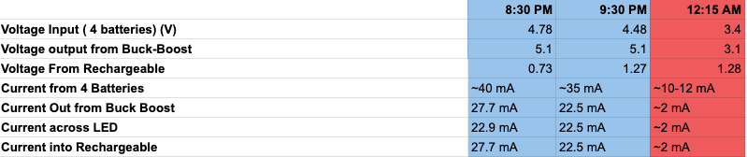

**Figure 5:** Prototype measurements (Test #1)

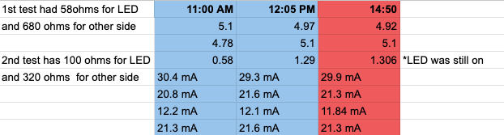

**Figure 6:** Prototype measurements (Test #2)

**5. Results**

The final product is a circuit in which the supplied current going into the NiMH battery is ~25 mA, where the input takes in 4 batteries and outputs to 1 NiMH battery. The overall circuit can be seen below:



**Figure 7:** Final Circuit Diagram (Again)

Here, the output from the buck boost should output around 5.2V, which is then fed towards a diode. This diode is to prevent the NiMH from self discharging into the circuit. Then, the circuit breaks up into a parallel circuit to divide the current into smaller portions. This is so that the LED doesn’t draw too much current, thus using less power. If there was simply just the LED and resistor and no parallel breakout, the current coming from the input batteries would increase as a result of keeping the same output current at 25 mA. The NiMH is connected to the end of the parallel breakout to join the currents back up again.

For calculating power efficiency, the output power was simply divided over the input power. To determine the power at both, the voltage of the 4 batteries was multiplied by the current that was drawn from it, while the output was calculated by the voltage at its node by the current going into it. This yields:

$Power Efficiency = 100 * \frac{0.105 W}{0.153W}=69\%$

Initially, the current to be used to charge was 250 mA, however, through testing, this discharged the 4 batteries too fast and didn’t provide enough voltage to the NiMH to be useful. This also proves to be more inefficient energy-wise. To combat this, a 25 mA charge rate was settled on, being 10x less than the initial current. Through this, the batteries lasted a lot longer and around 3-4 NiMH batteries were charged to around 80% each. The charge times depended on the starting voltage of the NiMH batteries, however, would typically be around 30-60 minutes. An NiMH battery wouldn’t be fully charge to 1.5V since a) they are rated to be 1.2V with an operating range between 0.9-1.35V according to the specifications on Duracell, and b) this rate of charging, being 0.01C, would mean that a fully charged battery would take 100 hours to charge. Since NiMH doesn’t need to be charged fully anyways and 80% capacity could be achieved, this was good enough.

To determine energy efficiency, the energy remaining graphs were used. By looking at the voltage vs % remaining and using that to determine the energy at that point, efficiency can be calculated. Since the batteries are in series, most of the batteries will drop relatively small amounts, while one, usually the battery that’s last in series, will be depleted more. By adding up the energies at each of these voltages, the total energy can be found. Also to note is that the energy remaining differs slightly for different discharge rates of current, however, the 10 mA discharge rate was used for the most similarity to the one used in the device. For the NiMH, a 0.1C discharge rate was used instead of the 0.2C rate. For determining the max energy in the batteries, 11 kJ was estimated from the alkaline graphs and 10.8 kJ was calculated from the capacity of 2500 mAh for the NiMH, where the the capacity is multiplied by the output voltage (1.2V) and then by time (3600 seconds).

|  | Voltage (V) | % Energy Remaining | Energy at that Percentage (kJ) | Total Energy (kJ) |
| --- | --- | --- | --- | --- |
| Starting Alkaline (1,2,3,4) | 1.22, 1.35, 1.16, 1.36 | 20, 32, 18, 32 | 2.2, 3.52 1.98, 3.52 | 11.2 |
| Starting Alkaline (avg) | 1.27 | 25.5 | 2.81 |
| Starting NiMH | 0.75 | 0 | 0 | 0 |
| Ending Alkaline (1,2,3,4) | 1.15, 1.3, 1.02, 1.32 | 18, 27, 15, 30 | 1.98, 2.97, 1.65, 3.3 | 9.9 |
| Ending Alkaline (avg) | 1.20 | 22.5 | 2.47 |
| Ending NiMH | 1.3 | 75 | 8.1 | 8.1 |

Table I

It can be seen that the ending NiMH energy was actually greater than the loss of energy from the 4 alkalines, while still charging around 75% capacity. This charge took around an hour, showing that not only can you charge at least 1 NiMH battery relatively quickly, but that you can actually charge at least another one. This of course depends on the starting voltages of the alkalines since it will vary. During the Capstone expo itself, around 3-4 NiMH batteries were actually charged with the same 4 input batteries although the charging was only to around 1.2-1.25V, or 20-35% capacity.

**6. Additional Design Considerations**

The environmental impact is the easiest to identify. The hope is that with the use of the Battery Vampire, people would be able to get more out of their AA batteries and therefore have to throw fewer batteries away. Even though there are specified battery recycling outlets, it is undeniable that some dead batteries just end up in the typical trash depositories. With a focus on recycling built into the Battery Vampire by nature of its design, we would hope to encourage not only the throwing away of less batteries, but also the responsible recycling of batteries when they have reached the end of their lifespan.

There would also be economic impacts. If this device were to be instituted on a broad scale there may be unforeseen impacts on the battery industry. While the battery industry would still be selling batteries, a decrease in the amount of batteries bought on a national level (which would theoretically happen if the Battery Vampire were to experience long term, widespread success) would be expected to happen. This could threaten the jobs of many people employed by the battery industry. However, this economic consideration does feed back into an environmental and even ethical consideration. As less batteries selling would translate to less batteries needing to be produced, which with the environmental and ethical concerns of mining rare earth metals, would be a net positive outcome of widespread use of the Battery Vampire.

**7. Cost Analysis**

The following is a list of expenditures related to the project.

$52.79 : Batteries in a Portable World: A Handbook on Rechargeable Batteries for Non-Engineers, Fourth Edition

$15.75 : Rechargeable StayCharged NiMH Batteries

$4.97 : Duracell Alkaline Powerboost AA4 Battery, 4 Count

$6.99 : LAMPVPATH (Pack of 8) AA Battery Holder Bundle 2Pcs Single AA Battery Holder, 2Pcs 2X 1.5V AA Battery Holder with Leads, 2Pcs 3X 1.5V 3 AA Battery Holder with Wire, 2Pcs 4X 1.5V 6 Volt Battery Holder

$9.69 : 4PCS Breadboards kit Include 2PCS 830 Point 2PCS 400 Point Solderless Breadboards for Proto Shield Distribution Connecting Blocks

$6.99 : LAMPVPATH (Pack of 2) 5 AA Battery Holder, 5 AA Battery Holder with Leads, 5 AA Battery Holder with Wires

$8.90 : SDTC Tech 2/4/6/8 x 1.5V AA Battery Holder with Snap COnnector Kit Include 3/6/9/12 Volt Battery Case Box and 1 Type Hard Shell Battery Clip Buckle Lead Wire

$29.85 : PowerBoost 500 Basic - 5V USB Boost @ 500mA from 1.8V+

$8.00 : Super Bright Red 5mm LED (25 pack)

$15.89 : GearLight M3 Mini LED Flashlight - 2 Bright, Small Tactical Flashlights with High Lumens and Pocket Clip for Camping, Outdoor & Emergency Use

$6.48 : LAMPVPATH (Pack of 6) Single AA Battery Holder, 1 X 1.5V AA Battery Holder with Leads Wires

$7.39 : 6Pcs AA Battery Holder with Leads Wires ON/Off Switch and Screw Cap Case Back Cover Connection 1.5V Battery Spring Clip Storage Box (1AA)

$17.42 : Duracell StayCharged AA Rechargeable Batteries

$8.99 : ElectroCookie Prototype PCB Solderable Breadboard for Electronics Projects Compatible for DIY Arduino Soldering Projects, Gold-Plated (5 Pack + 1 Mini Board, Red)

$7.99 : ElectroCookie Mini PCB Prototype Board Solderable Breadboard for DIY Electronics, Compatible for Mini Arduino Soldering Projects, Gold-Plated (6 Pack, Multicolor)

The project was very cost effective and there is no current plan to either mass produce this product, nor

continue the project and therefore there are no potential future costs to account for here.

**8. Conclusions and Recommendations**

The Battery Vampire 1.0 gave us a solid base design concept to work from and to improve on. Starting from their attempt at the same project we were able to come up with a very simple yet effective solution to achieve the desired outcome of this project. The Battery Vampire 1.0 primarily featured a homemade and home-soldered charging circuit which was wildly inefficient at taking energy from the dead batteries. It also only took that energy and used it to charge a power bank. After reviewing their final design report we had a good idea of the direction we should go to create an even better iteration of the Battery Vampire. The most important design change we made was to buy a buck-boost converter, the PowerBoost 500 Basic, instead of hand building our own battery charging circuit. By doing this we were able to greatly increase energy efficiency over the Battery Vampire 1.0. We were also able to design a circuit that allowed the Battery Vampire 2.0 to be capable of AA battery to AA battery charging instead of charging an external power bank which was more in line with the professors expectations. We also integrated an LED into the circuit to provide an identifier to the user of the Battery Vampire 2.0 as to when it was time to switch out their dead batteries. Based on the nature of our project there were not many alternative design options considered. From idea conception to product realization we had a plan and a general design that we were trying to stick to and we were successful in this endeavor. The only potential alternatives that we seriously considered were different amounts of batteries being on either the input or the output side of the Battery Vampire 2.0. In our final prototype we built, the Battery Vampire 2.0 was able to take energy from four batteries and use that energy to charge a single rechargeable battery, but this was not always the case. Early on when we were brainstorming the project we considered having the vampire take 8 batteries or charge 2 or 3 batteries. We ended up choosing the four to one ratio as we thought it was the best choice to prove our concept worked and was also the most energy efficient solution given our components that we had chosen for this project.

During the Course of this project we accomplished several meaningful milestones. We all had to become familiar with battery functionality and how batteries can be used to interact with each other in the ways we needed them too. We were able to come up with a design for a functional prototype that would meet all of our professors laid out requirements. We bought the materials for the Battery Vampire 2.0, we built the machine, and then we tested it several times to make sure it was fully functional. There are a variety of ways this product could be changed depending on the situation. For example, while the component values would have to be changed the same logic used in this project could be used to create a Battery Vampire for any type of battery not just AA batteries. You could also think about redesigning the system so that a different ratio of charging batteries to batteries being charged could be used (four to two for instance instead of the standard four to one). Through the course of doing our project we came to the conclusion that the final product had a relatively limited use case. According to a study done by the university of Illinois the average person only throws away about 8 batteries every year5. While this does add up in the grand scheme of things, because there are billions of people all over the word who use batteries, the average person does not use enough batteries to get much value out of a device like this. If this project were to be continued in the future that is the biggest problem that would need to be addressed. How to make a marketable device that would have an environmental impact if used by everyone, but if used by a single person will make an imperceivable difference. However this is probably more of a marketing problem than an engineering problem.

**References**

[1] Duracell, “Alkaline-Manganese Dioxide Battery,” MN15USCT0122 datasheet, (accessed Nov. 15 2023).

[2] Duracell, “Nickel Metal Hydride Battery AA 2500mAh, ” AA25HP1118 datasheet, (accessed Nov. 15 2023).

[3] Duracell, “Alkaline-Manganese Dioxide Battery,” MN15USCT0122 datasheet, (accessed Nov. 15 2023).

[4] G. Barbehenn, “2.7V to 38V Vin range, low noise, 250ma Buck-Boost Charge Pump converter,” Analog Devices,

[5] *Libguides: Battery Recycling: Battery Recycling Facts*. Battery recycling facts - Battery Recycling - LibGuides at University of Illinois at Urbana-Champaign. https://guides.library.illinois.edu/battery-recycling (accessed May 1 2024)

**Appendix A – Team Contract**

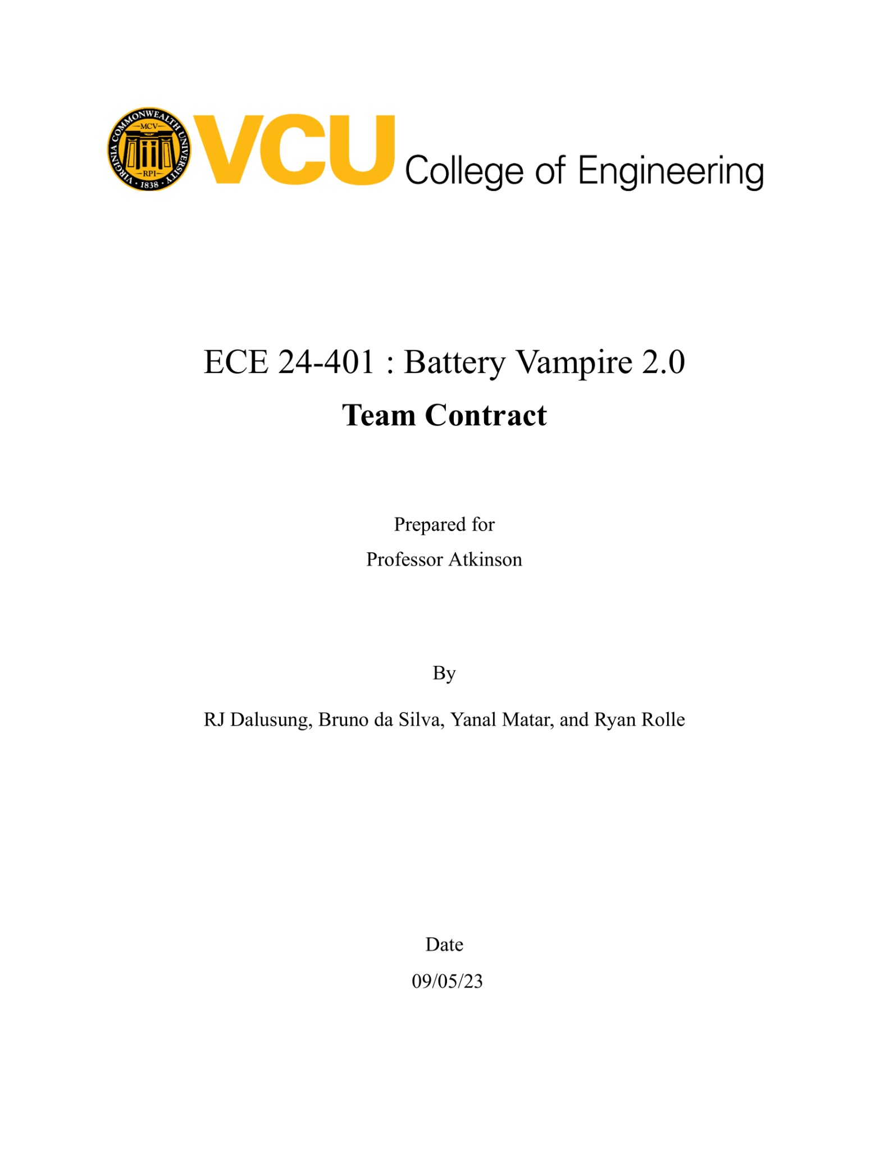



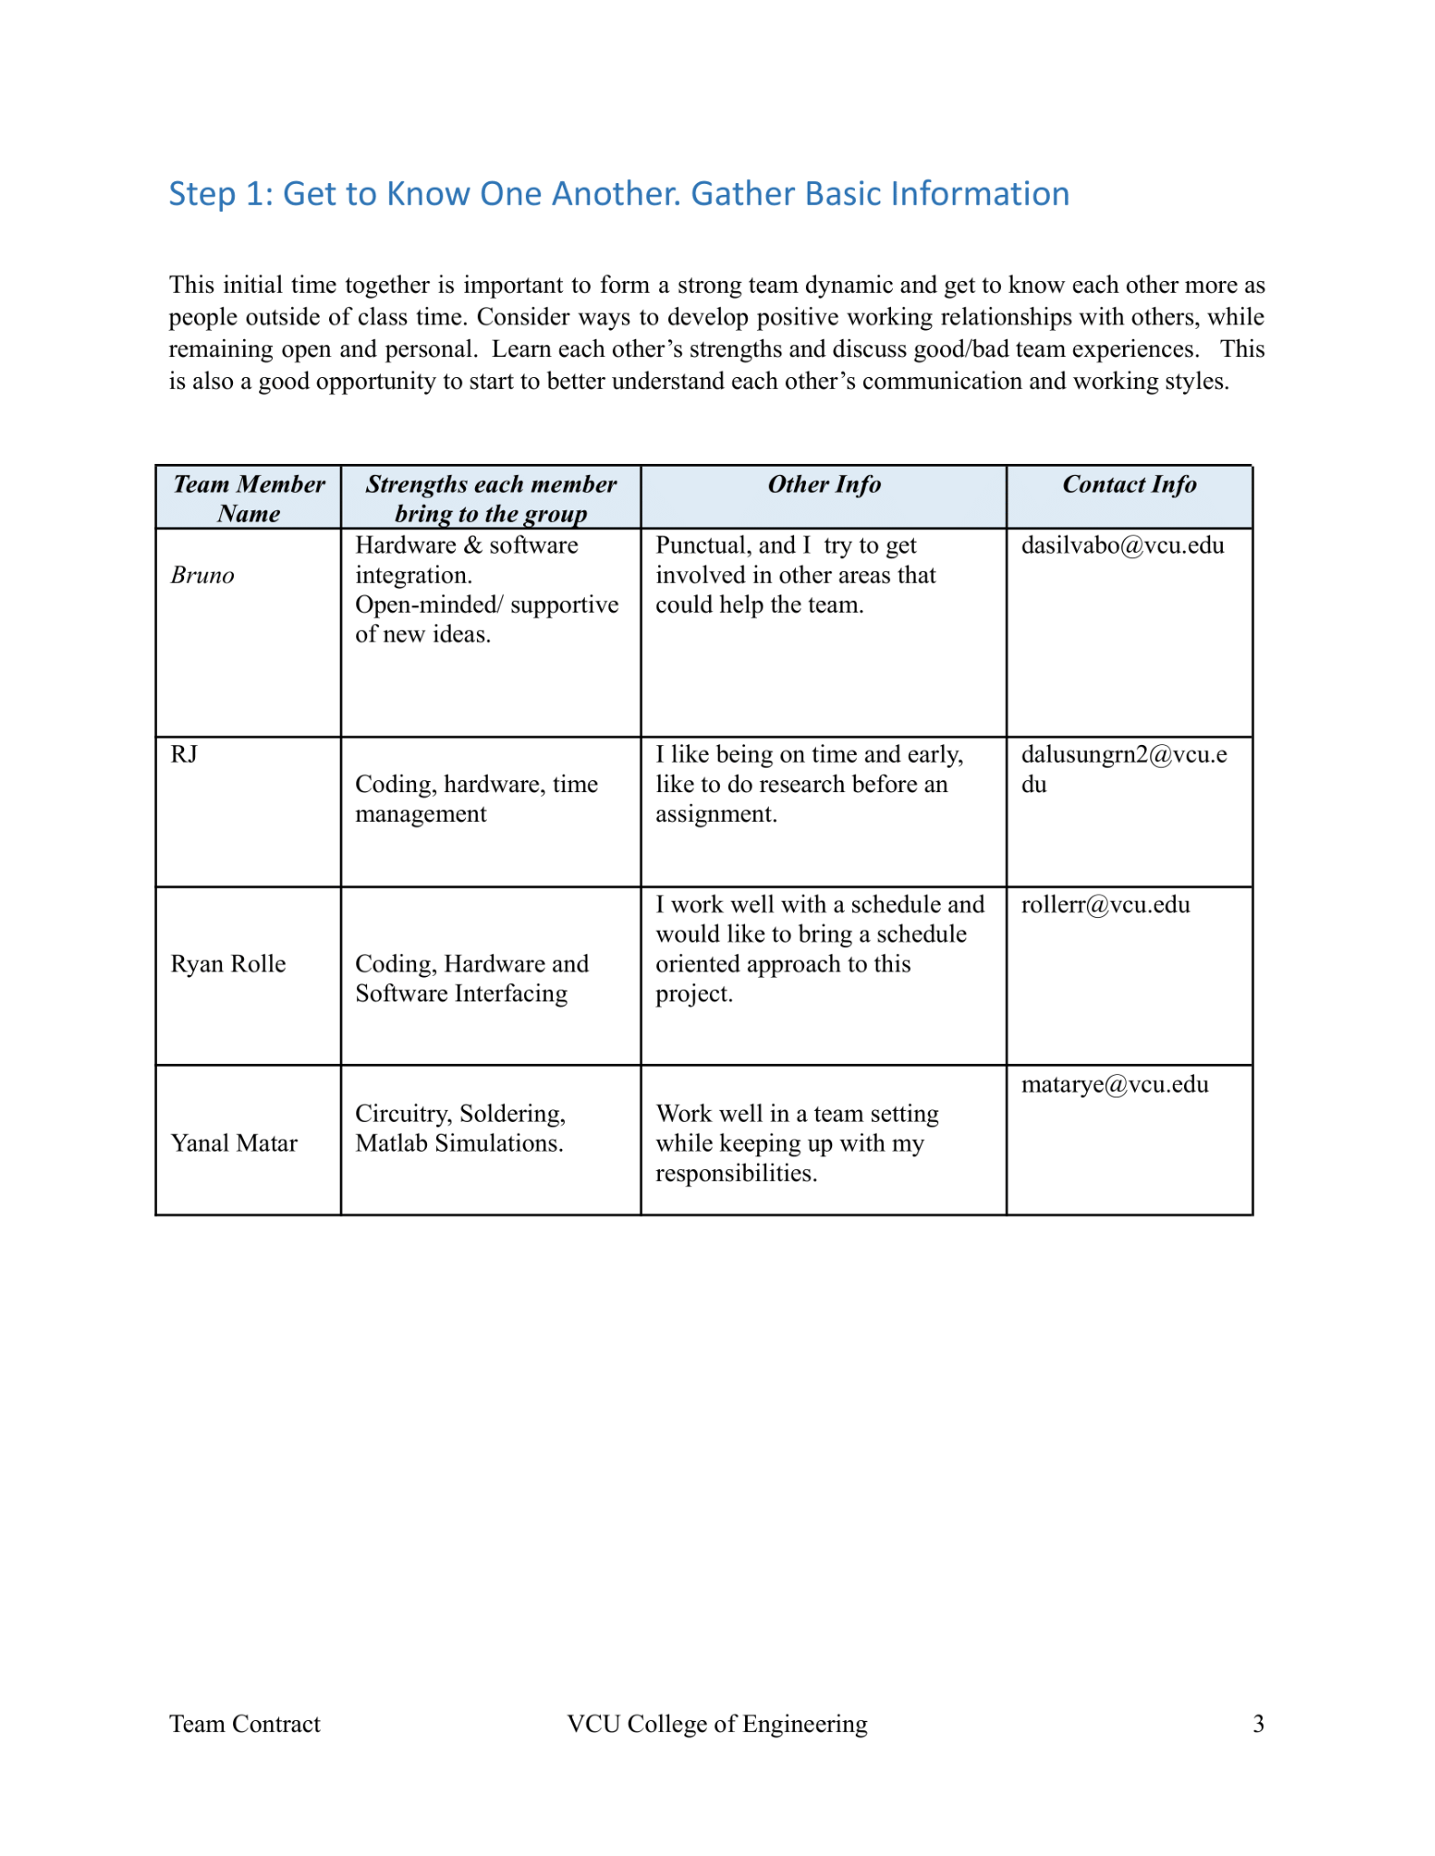



**Appendix B – Schedule/Timeline**

| **WBS NUMBER** | **TASK TITLE** | **TASK OWNER** | **START DATE** | **DUE DATE** | **DURATION (Days)** |
| --- | --- | --- | --- | --- | --- |
|
|
|  | **Tasks and Activities** |  |  |  |  |
| 1 | Gather Materials |  | 1/17/2023 | 2/1/2024 | 46 |
| 2 | Build Prototype |  | 2/1/2024 | 3/1/2024 | 30 |
| 2 | Measure Energy Efficiency |  | 2/15/2024 | 3/15/2024 | 30 |
| 3 | Improve Initial Designs |  | 3/1/2024 | 3/15/2024 | 14 |
| 4 | Write Design Report |  | 3/1/2023 | 4/1/2023 | 30 |
| 6 | Put Together Final Product |  | 3/15/2024 | 4/1/2024 | 16 |
| 7 | Spring Poster and Abstract |  | 3/15/2024 | 4/1/2024 | 16 |

| **January** | | | | | | | | | | | | | | | | | | | |
| --- | --- | --- | --- | --- | --- | --- | --- | --- | --- | --- | --- | --- | --- | --- | --- | --- | --- | --- | --- |
| **WEEK 13** | | | | | **WEEK 14** | | | | | **WEEK 15** | | | | | **WEEK 16** | | | | |
| **M** | **T** | **W** | **R** | **F** | **M** | **T** | **W** | **R** | **F** | **M** | **T** | **W** | **R** | **F** | **M** | **T** | **W** | **R** | **F** |
|  |  |  |  |  |  |  |  |  |  |  |  |  |  |  |  |  |  |  |  |
|  |  |  |  |  |  |  |  |  |  |  |  |  |  |  |  |  |  |  |  |
|  |  |  |  |  |  |  |  |  |  |  |  |  |  |  |  |  |  |  |  |
|  |  |  |  |  |  |  |  |  |  |  |  |  |  |  |  |  |  |  |  |
|  |  |  |  |  |  |  |  |  |  |  |  |  |  |  |  |  |  |  |  |
|  |  |  |  |  |  |  |  |  |  |  |  |  |  |  |  |  |  |  |  |
|  |  |  |  |  |  |  |  |  |  |  |  |  |  |  |  |  |  |  |  |
|  |  |  |  |  |  |  |  |  |  |  |  |  |  |  |  |  |  |  |  |
|  |  |  |  |  |  |  |  |  |  |  |  |  |  |  |  |  |  |  |  |
|  |  |  |  |  |  |  |  |  |  |  |  |  |  |  |  |  |  |  |  |
|  |  |  |  |  |  |  |  |  |  |  |  |  |  |  |  |  |  |  |  |
|  |  |  |  |  |  |  |  |  |  |  |  |  |  |  |  |  |  |  |  |
|  |  |  |  |  |  |  |  |  |  |  |  |  |  |  |  |  |  |  |  |
|  |  |  |  |  |  |  |  |  |  |  |  |  |  |  |  |  |  |  |  |
|  |  |  |  |  |  |  |  |  |  |  |  |  |  |  |  |  |  |  |  |
|  |  |  |  |  |  |  |  |  |  |  |  |  |  |  |  |  |  |  |  |
|  |  |  |  |  |  |  |  |  |  |  |  |  |  |  |  |  |  |  |  |

| **February** | | | | | | | | | | | | | | | | | | | |
| --- | --- | --- | --- | --- | --- | --- | --- | --- | --- | --- | --- | --- | --- | --- | --- | --- | --- | --- | --- |
| **WEEK 17** | | | | | **WEEK 18** | | | | | **WEEK 19** | | | | | **WEEK 20** | | | | |
| **M** | **T** | **W** | **R** | **F** | **M** | **T** | **W** | **R** | **F** | **M** | **T** | **W** | **R** | **F** | **M** | **T** | **W** | **R** | **F** |
|  |  |  |  |  |  |  |  |  |  |  |  |  |  |  |  |  |  |  |  |
|  |  |  |  |  |  |  |  |  |  |  |  |  |  |  |  |  |  |  |  |
|  |  |  |  |  |  |  |  |  |  |  |  |  |  |  |  |  |  |  |  |
|  |  |  |  |  |  |  |  |  |  |  |  |  |  |  |  |  |  |  |  |
|  |  |  |  |  |  |  |  |  |  |  |  |  |  |  |  |  |  |  |  |
|  |  |  |  |  |  |  |  |  |  |  |  |  |  |  |  |  |  |  |  |
|  |  |  |  |  |  |  |  |  |  |  |  |  |  |  |  |  |  |  |  |
|  |  |  |  |  |  |  |  |  |  |  |  |  |  |  |  |  |  |  |  |
|  |  |  |  |  |  |  |  |  |  |  |  |  |  |  |  |  |  |  |  |
|  |  |  |  |  |  |  |  |  |  |  |  |  |  |  |  |  |  |  |  |
|  |  |  |  |  |  |  |  |  |  |  |  |  |  |  |  |  |  |  |  |
|  |  |  |  |  |  |  |  |  |  |  |  |  |  |  |  |  |  |  |  |
|  |  |  |  |  |  |  |  |  |  |  |  |  |  |  |  |  |  |  |  |
|  |  |  |  |  |  |  |  |  |  |  |  |  |  |  |  |  |  |  |  |
|  |  |  |  |  |  |  |  |  |  |  |  |  |  |  |  |  |  |  |  |
|  |  |  |  |  |  |  |  |  |  |  |  |  |  |  |  |  |  |  |  |
|  |  |  |  |  |  |  |  |  |  |  |  |  |  |  |  |  |  |  |  |

| **March** | | | | | | | | | | | | | | | | | | | |
| --- | --- | --- | --- | --- | --- | --- | --- | --- | --- | --- | --- | --- | --- | --- | --- | --- | --- | --- | --- |
| **WEEK 21** | | | | | **WEEK 22** | | | | | **WEEK 23** | | | | | **WEEK 24** | | | | |
| **M** | **T** | **W** | **R** | **F** | **M** | **T** | **W** | **R** | **F** | **M** | **T** | **W** | **R** | **F** | **M** | **T** | **W** | **R** | **F** |
|  |  |  |  |  |  |  |  |  |  |  |  |  |  |  |  |  |  |  |  |
|  |  |  |  |  |  |  |  |  |  |  |  |  |  |  |  |  |  |  |  |
|  |  |  |  |  |  |  |  |  |  |  |  |  |  |  |  |  |  |  |  |
|  |  |  |  |  |  |  |  |  |  |  |  |  |  |  |  |  |  |  |  |
|  |  |  |  |  |  |  |  |  |  |  |  |  |  |  |  |  |  |  |  |
|  |  |  |  |  |  |  |  |  |  |  |  |  |  |  |  |  |  |  |  |
|  |  |  |  |  |  |  |  |  |  |  |  |  |  |  |  |  |  |  |  |
|  |  |  |  |  |  |  |  |  |  |  |  |  |  |  |  |  |  |  |  |
|  |  |  |  |  |  |  |  |  |  |  |  |  |  |  |  |  |  |  |  |
|  |  |  |  |  |  |  |  |  |  |  |  |  |  |  |  |  |  |  |  |
|  |  |  |  |  |  |  |  |  |  |  |  |  |  |  |  |  |  |  |  |
|  |  |  |  |  |  |  |  |  |  |  |  |  |  |  |  |  |  |  |  |
|  |  |  |  |  |  |  |  |  |  |  |  |  |  |  |  |  |  |  |  |
|  |  |  |  |  |  |  |  |  |  |  |  |  |  |  |  |  |  |  |  |
|  |  |  |  |  |  |  |  |  |  |  |  |  |  |  |  |  |  |  |  |
|  |  |  |  |  |  |  |  |  |  |  |  |  |  |  |  |  |  |  |  |
|  |  |  |  |  |  |  |  |  |  |  |  |  |  |  |  |  |  |  |  |

| **April** | | | | | | | | | | | | | | | | | | | |
| --- | --- | --- | --- | --- | --- | --- | --- | --- | --- | --- | --- | --- | --- | --- | --- | --- | --- | --- | --- |
| **WEEK 25** | | | | | **WEEK 26** | | | | | **WEEK 27** | | | | | **WEEK 28** | | | | |
| **M** | **T** | **W** | **R** | **F** | **M** | **T** | **W** | **R** | **F** | **M** | **T** | **W** | **R** | **F** | **M** | **T** | **W** | **R** | **F** |
|  |  |  |  |  |  |  |  |  |  |  |  |  |  |  |  |  |  |  |  |
|  |  |  |  |  |  |  |  |  |  |  |  |  |  |  |  |  |  |  |  |
|  |  |  |  |  |  |  |  |  |  |  |  |  |  |  |  |  |  |  |  |
|  |  |  |  |  |  |  |  |  |  |  |  |  |  |  |  |  |  |  |  |
|  |  |  |  |  |  |  |  |  |  |  |  |  |  |  |  |  |  |  |  |
|  |  |  |  |  |  |  |  |  |  |  |  |  |  |  |  |  |  |  |  |
|  |  |  |  |  |  |  |  |  |  |  |  |  |  |  |  |  |  |  |  |
|  |  |  |  |  |  |  |  |  |  |  |  |  |  |  |  |  |  |  |  |
|  |  |  |  |  |  |  |  |  |  |  |  |  |  |  |  |  |  |  |  |
|  |  |  |  |  |  |  |  |  |  |  |  |  |  |  |  |  |  |  |  |
|  |  |  |  |  |  |  |  |  |  |  |  |  |  |  |  |  |  |  |  |
|  |  |  |  |  |  |  |  |  |  |  |  |  |  |  |  |  |  |  |  |
|  |  |  |  |  |  |  |  |  |  |  |  |  |  |  |  |  |  |  |  |
|  |  |  |  |  |  |  |  |  |  |  |  |  |  |  |  |  |  |  |  |
|  |  |  |  |  |  |  |  |  |  |  |  |  |  |  |  |  |  |  |  |
|  |  |  |  |  |  |  |  |  |  |  |  |  |  |  |  |  |  |  |  |
|  |  |  |  |  |  |  |  |  |  |  |  |  |  |  |  |  |  |  |  |